*Table of Contents Pg no.*

*Portfolio 1.1 -----------------------------------------------------------------------------------*

*Portfolio 1.2 -----------------------------------------------------------------------------------*

*Portfolio 1.3 -----------------------------------------------------------------------------------*

*Portfolio 1.4 -----------------------------------------------------------------------------------*

*Portfolio 1.5-----------------------------------------------------------------------------------*

*Portfolio 1.6 -----------------------------------------------------------------------------------*

# **Portfolio 1.1**

**Project Proposal**

Designing the Website for House of Cards Offline Store

**Site Title**: House of Cards

**Developer and Role**:

I will develop the site with specifications and requirements provided by the client. The end products will satisfy the client (House of cards) with the design provided to him

**Project Focus:**

The goal is to design a site with good user interaction and provide as much information as possible to the visitor would would like to know about the House of card business

* The content of the site would be purely informational and images provided by the client

**Planning the Website:**

1. **Main Elements Outline**

* Visitor can navigate using the navigation menu provide on the top of every page
* Visitor can go to home page by clicking the logo placed on left of the page
* Stylish transitions and effects are added to images with thumbnail and grid view

1. **Content:**

* The overall content of the site is divided into sections and pages, the estimated individual pages will be approximately 26pages

1. **Target Audiences:**

* Audience will surf the application to know more about the business and service provided by the House of Cards.

1. Design Considerations:

* Design the application that is easy to use
* Allow the user to experience the business of House of cards and attain enough knowledge about their work
* Give insights about the offline business and list of products that area available.

1. Limiting factors:

Technical:

* No tools should be used
* No scripting should be used as it limits the user interaction to be with static pages and content on the site
* Cannot shop online

Audience Factors:

* Audience are allowed to view the site but cannot interact dynamically
* No specific user profile is created to audience if they wanted
* Cannot contact the website admin or owner with the application

**Portfolio 1.2:**

**Home page:**

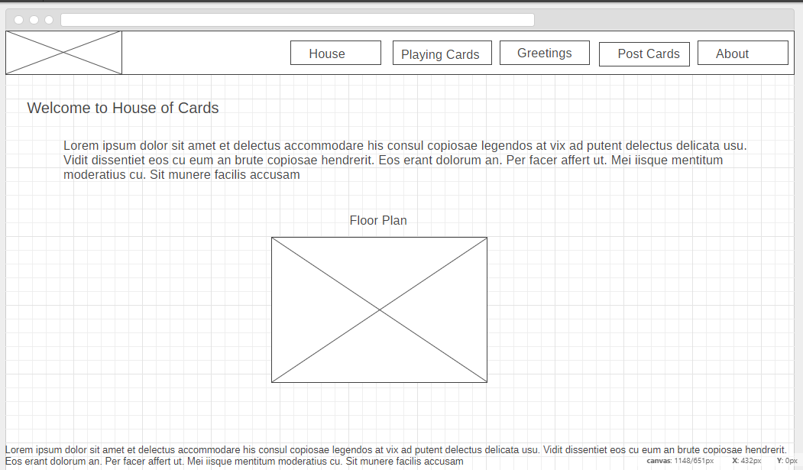

Figure: index page Wireframe

**Cards View Page:**

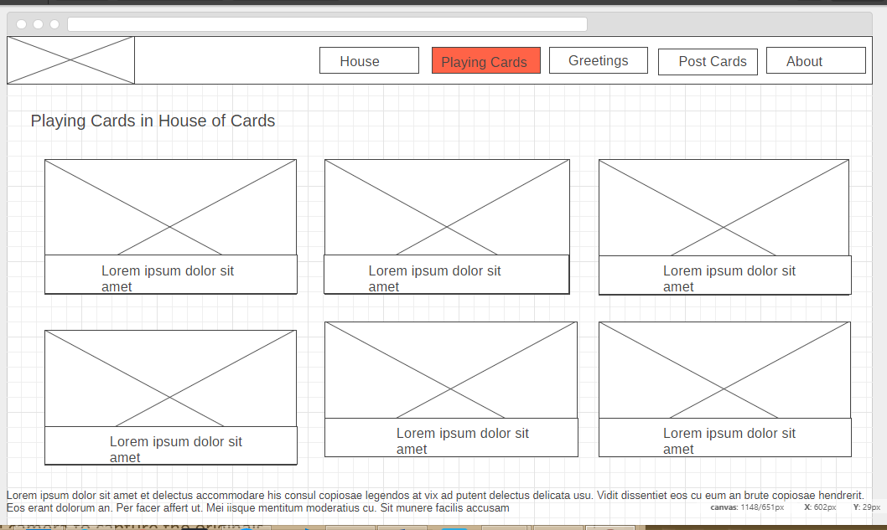

Figure: Greetings page thumbnail view

**About page:**

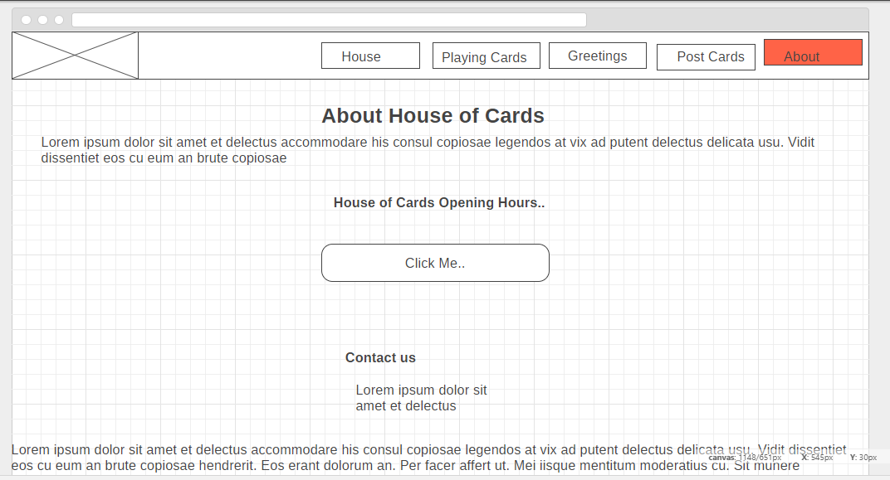

Figure: Contact and about us

***Portfolio 1.3***

**Website Specification:**

**Client**: House of Cards

**Specifications**:

* Logo should be contained in every document
* No data should be altered or modified
* Headings, titles, padding, margins can be used by developer itself
* Users must be able to grab the information by browsing the pages
* Provide as much information as possible to all the users about the business.
* Shop layout in the form of floor plan must be shown to the user.
* User should be able to navigate to the require page by clicking on the floor plan
* Design the site that is easy for everyone to navigate and find information

**Success Measurement:**

1. Design the application with given specification with good quality design and coding standards
2. Increase the business revenue
3. Able to spread the word of business about House of Cards
4. Personal user’s like about the business and website

**Mission Statement**:

The mission of this project is to develop a website for House of Cards client to know their business model and service by the users who have or haven’t visited the store.

**Target Audience:**

All Audience who has interest in different types of cards are targeted, and they don’t include any kind of age restrictions. Different age groups are targeted to attract and increase the business traffic in both offline and online

**Technical Limitations for Developing:**

* No mark-up language should be used other than HTML5 and css3 to develop the website
* Rapid Application Development tools must be avoided in designing the website
* No external services or add on must be used, for browsing or opening the site

**Flow Chart Diagram**

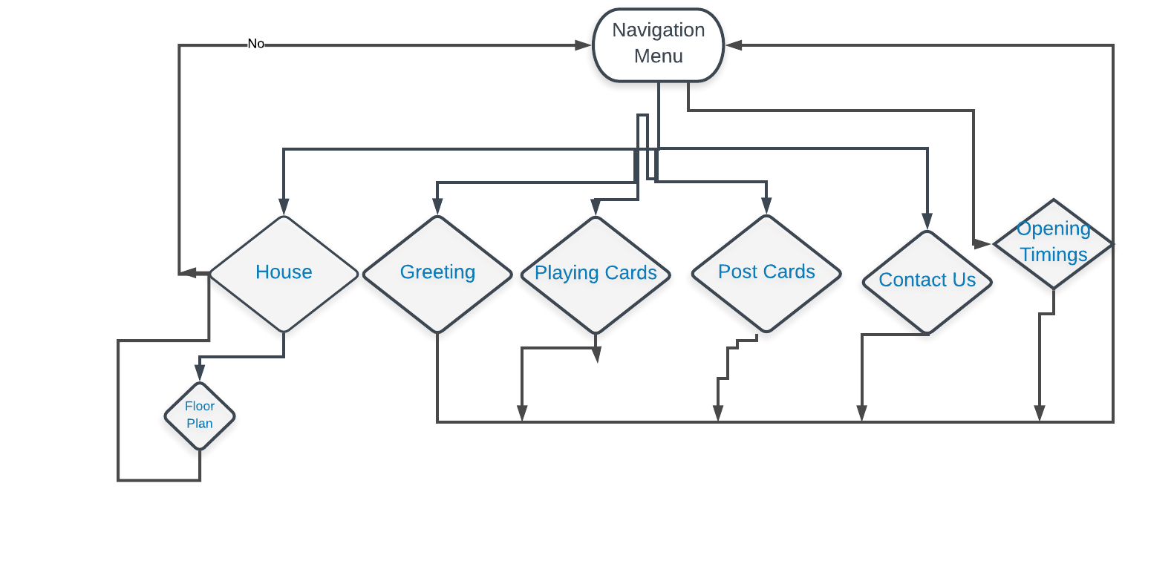

Figure: Flow chart

***Flow Description:***

1. Navigation menu has links to other pages of the site
2. User can visit the home page or home by clicking on the home or logo on navigation menu
3. Stylesheets are applied to all pages in the header of the document
4. Individual pages are also linked to main menu and navigation bar:

This structure is chosen as it is effective in nature and functionality, and no broken link can be found from page to page navigation. Any type of person can easily map the site by clicking menu 2 or more times and directly get the content which is desired

***Portfolio 1.4***

**Implementing CSS Design:**

1. CSS styles can be applied in 3 ways :

* Inline
* Internal
* External

1. External stylesheets are used for this website as it is easy to link the pages and write common classes all over the documents
2. Class names are added wherever necessary and called them in styles and applied respective properties
3. Class names identify individual or group of elements and apply different properties
4. Different typographies, whitespaces, content modification, colours, background colours, css effects, transitions, paddings, margins and many more can be applied to one or more classes at a time
5. HTML tags also used to identify in document and apply style to it.

List of possible CSS Class names:

* Navigation class - navigation menu and links
* Brand-logo - for logo image
* .nav-menu – For menu list
* Unordered-list class – for ul and li elements container
* .brand-message class- for House of cards intro text and description
* Map section class- for floor plan and its title

**HTML5 sections:**

HTML document should have default body and head section, and these further can be divided into many as required

1. Head tag/section
2. Body tag/Section
3. Footer tag/Section

Head

[

[meta-tags]

[stylesheets link]

[other links if necessary]

]

Body

[

[header or navigation menu]

[list of menu items]

[logo]

[container]

]

Footer

[

[footer class]

[Footer text]

[footer class ends]

]

***Portfolio 1.5:***

Type hierarchy of the Website

1. Navigation menu is placed at top of the pages
2. Heading and welcome messages are placed right below the menu
3. Description the website and demo is placed in the main body container
4. Floor plan is placed to give insight of the business structure in offline who wants to visit
5. Footer contains links to social media platform of the business and copyright information about the assets and business

Typographic Schema:

1. Default typographic shame is used as the text rendered on the browser is quite simple and neat
2. Six levels are headings are necessary as there might be titles at different pages to indicate the boldness and importance of the text.
3. Bold and italics are used frequently in font-weight property and sizes are increased as default text size is smaller than needed
4. Em tags or <i> </i> tags can be used to emphasize in various browsers
5. Readability and legibility can be ensured by altering the default font sizes and line heights of the texts
6. Line length is changed according to the paragraph mostly it is in between 1.2 to 1.6

**Portfolio 1.6.**

* Css box model wraps around the elements
* CSS box model typically has borders, paddings, margins and the content of the element
* Without the css box model the elements clutter and cannot be read properly.
* CSS box model allows all the html elements to wrap around other elements with required amount of paddings, borders and margins.
* This website is designed by taking the advantage of css box model for best possible outcome of the proposed design

**Box model Demo**

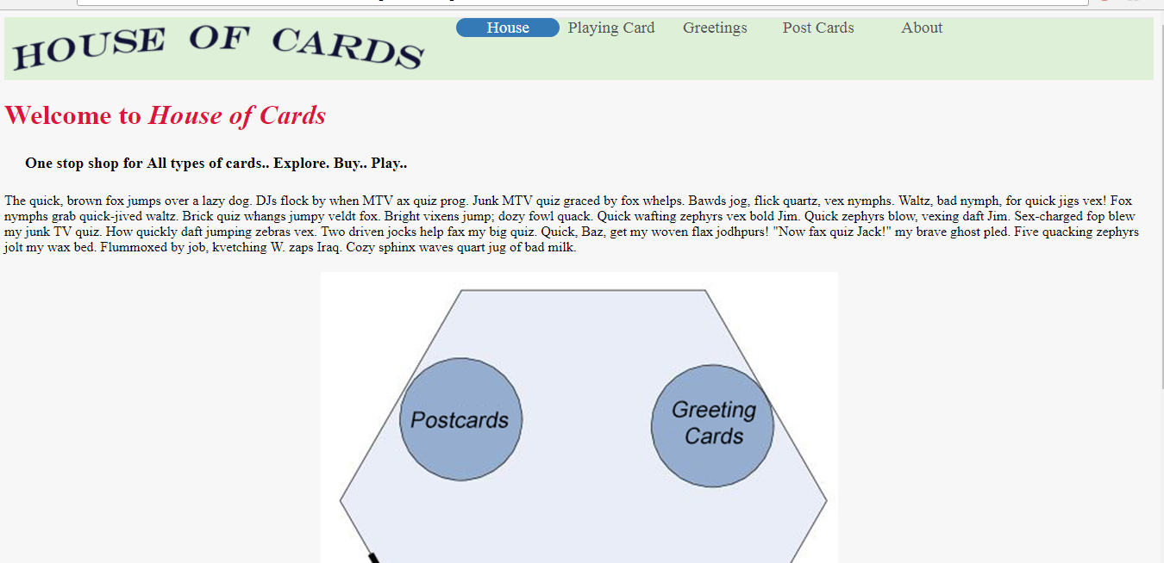

Figure: Box model when paddings, margin and borders removed

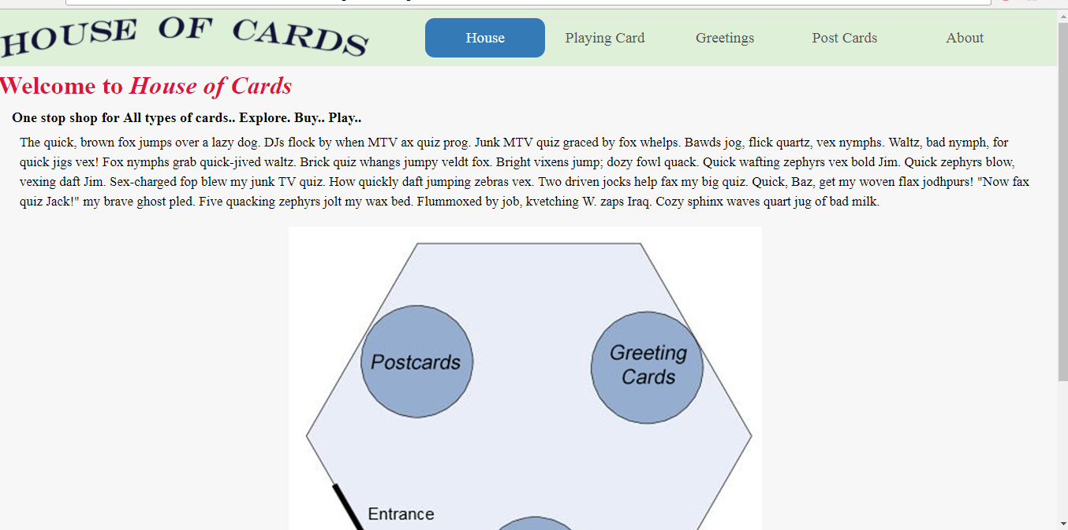

Figure: Box model after using paddings, margins and borders